Project Development Phase
Performance Test

Date | 20/10/2026
Team ID | Shried Mandloi
Project Name | Electric Vehicle Market Performance & Insights
Maximum Marks

Project Performance Testing:

S.No. | Parameter | Screenshot / Values
 | Data Rendered | 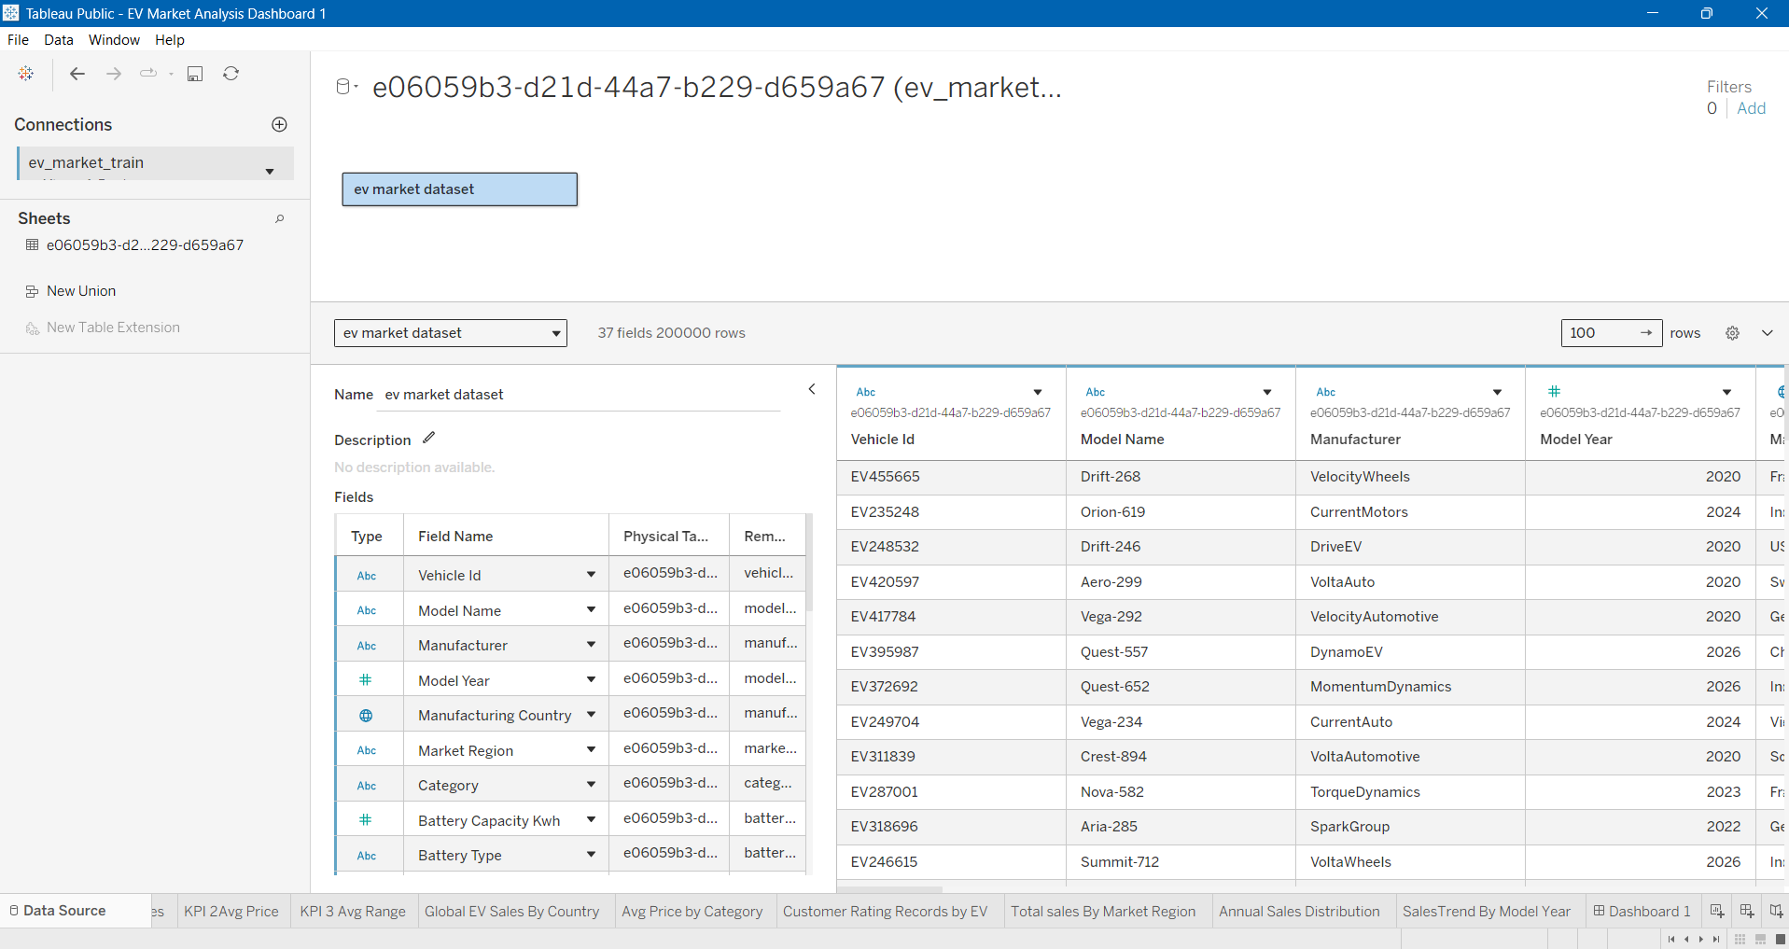
 | Data Preprocessing | Checked the dataset for null values and converted fractional values into decimal format to ensure consistency and accuracy during analysis and visualization.
3. | Utilization of Filters | 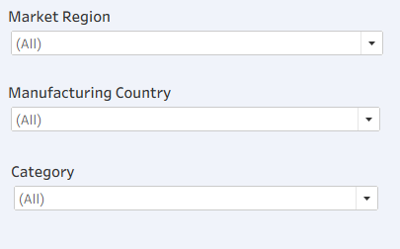
4. | Calculation fields Used | Created calculated fields and aggregations in Tableau to derive key performance metrics such as Total Sales, Average Price and Average Range. These calculations were used to compare EV categories, manufacturers, regions, and other market segments and support the dashboard visualizations.
5. | Dashboard design | No of Visualizations / Graphs – 9  https://public.tableau.com/views/EVMarketAnalysisDashboard1/Dashboard1?:language=en-US&publish=yes&:sid=&:redirect=auth&:display_count=n&:origin=viz_share_link  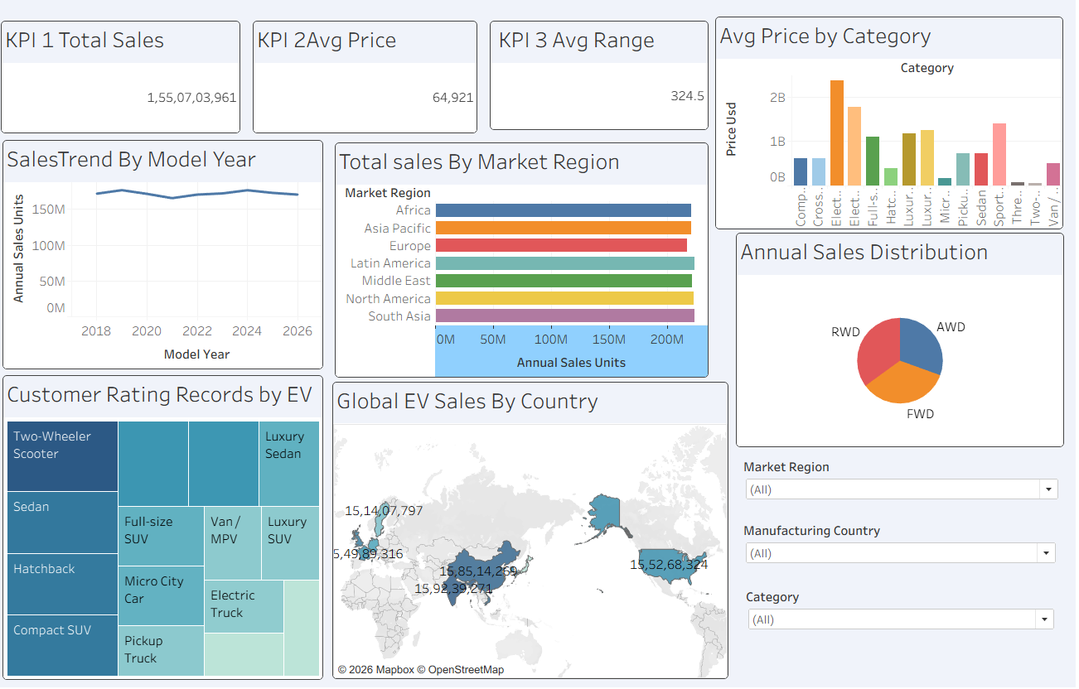
6 | Story Design | No of Visualizations / Graphs -9  https://public.tableau.com/views/EVMarketAnalysisStorypublish/Story1?:language=en-US&publish=yes&:sid=&:redirect=auth&:display_count=n&:origin=viz_share_link  